Acknowledgement

We express our sincere thanks Mr. Bryan Kerr (HOD) of BCA (SCS), for providing us this excellent opportunity to undergo such wonderful and effective in curriculum training. It has truly been an engrossing an invaluable experience and provided us with much needed corporate exposure and awareness

We would like to special thank teachers of bca with whom we have been associated during the project work and who have been our guide and mentor throughout the project period. Their keen interest in our project and the invaluable guidance and support that they have provide us through the two month needs special mention.

We are gratefully indebted to them and express our sincere gratitude to them for their kind co-operation.

**Contents**

1. INTRODUCTION
2. OBJECT
3. ANALYSIS DOCUMENT
4. SYSTEM ANALYSIS
5. FEASIBILITY STUDY
6. PLATFORM
7. HTML, CSS & PHP WITH MYSQL
8. SERVER
9. TEAM STRUCTURE
10. DATA FLOW DIAGRAM(DFD)
11. ENTITY RELATIONSHIP DIAGRAM(ERD)
12. DATABASE SCHEME
13. SNAPSHOTS
14. TESTING
15. CONCLUSION
16. FURTHER SCOPE
17. BIBLIOGRAPHY

**Analysis document**

Requirement analysis is a software engineering task that bridge the gap between system level requirements engineering and software design. The goal of the requirement gathering activity is to collect all relevant information from the customer regarding the product to be developed with a view to clearly understanding the customer’s requirement. Requirement analysis allows the software engineer to refine the software allocation and build models of the data, functional, behavior domains that will be treated by software. Requirement analysis provides the software designer with a representation of information, function, behavior that can be translated to data , architectural, interface, and component-level designs.

Our “alpine lodge” is based on advance booking of room. It include three rooms; each room with its own unique style, and personality. We also have dining for upto 20, with ATM facilities in the lodge itself for safe and easy access of cash.

The infrastructure development of this website are:

* Alpine lodge/ organized by contacts
* Advance booking
* Facility for ATM
* Unique rustic accommodation
* Updated with daily climate

In our website there are two field to visiting users, one who register them by this website and get their booking. Client user can contact with the manager through ‘contact’ option the administrator must login by entering secured ID and password details.

**INTRODUCTION**

Overview of the project

It is the website which is very much useful for the people from place as they can easily and comfortably book early as an Alpine lodge is a unique rustic accommodation, providing guest rooms for travelers and a function room for you event or meeting. The breathtaking beauty or this wonderful part of Sikkim is all around you when staying with us at alpine lodge.

OBJECTIVE

Before a project can be planed, product objective and information for student be established, it is because a developer should know why he is making the software or what the utility of the software is. In broad sense we can call it as the goal of the software.

The goal of making this website is to make person aware of beautiful landscape of south Sikkim and for the advertisement of a certain lodge i.e., alpine. It is therefore helps to honor for the accuracy of the customer for the proper arrangement.

**System analysis**

System development can generally be thought of as having two major components in which one such component is system analysis. System analysis is the process of gathering and interpreting facts, diagnosing problems and using the information to recommend improvement to the system. Analysis is a detail study of the various operation performed by a system and their relationship within and outside of the system. One aspect of analysis is defining the boundaries of the system and determining whether or not a candidate system should consider other related systems. During analysis, data are collected on the available files, decision points and transactions handled by the present system. Data Flow Diagrams, interviews, on site observations and questionnaires and commonly used tools in analysis. We can say that analysis specifies what the system should do. System analysis is the management technique, which helps us in designing a new system, improving an existing system or solving a system problem.

System analysis is an important activity that takes place when we are building new information system on changing existing one. Basically it is necessary to set up the right procedures to ensure that call the organizations personal have all the data needed for their work. The investigation into system operation and possible changes to the system is called System Analysis.

Software project scope must be unambiguous and understandable at the management and the technical levels. A statement of software scope must be bounded. That is, quantitative data are stated explicity; constrains and limitations.

**Feasibility study**

A feasibility study aims to objectively and rationally uncover the strengths and weaknesses of an existing business or proposed venture, opportunities and threats present in the natural environment, the resources required to carry through, and ultimately the prospects for success.In its simplest terms, the two criteria to judge feasibility are cost required and value to be attained.

A well-designed feasibility study should provide a historical background of the business or project, a description of the product or service, accounting statements, details of the operations and management, marketing research and policies, financial data, legal requirements and tax obligations.Generally, feasibility studies precede technical development and project implementation.

A feasibility study evaluates the project's potential for success; therefore, perceived objectivity is an important factor in the credibility of the study for potential investors and lending institutions.  It must therefore be conducted with an objective, unbiased approach to provide information upon which decisions can be based

Types of feasibility study:

1. Economical feasibility study
2. Technical feasibility study
3. Operational feasibility study

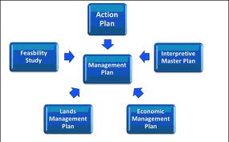

**PLATFROM**

Software Environment:- MysQl and PHP has been used for the implementation of the website. Here the MySQL is used for making database of entities. This website can be displayed by the web browser like: Monzilla firefox, opera , google crome & internet Explorer.

Hardware Environment:- Minimum hardware required for browsing the website is as follows:

* Intel Pentium dual core processor T4500(2.3 GHz,800 MHZ FSB)
* Intel GMA 4500M
* 320 GB HDD
* CD/DVD- ROM Writer
* 3 GB DDR3 RAM

**PHP**

PHP is a general- purpose scripting language that is especially suited to server- side web development where PHP generally runs on a web server. Any PHP code in a requested file is executed by the PHP runtime, Usually to create dynamic web page content. It can also be used be used for command-line scripting and client-side GUI applications. PHP can be deployed on most web servers, many operating systems and platforms, and can be used with many relational database management systems. It is available free of charge, and the PHP Group provides the complete source code for users to build, customize and extend for their own use.

PHP primarily acts as a filter, taking input from a file or stream containing text and/or PHP instructions and outputs another stream of data; most commonly the output will be HTML. Since PHP 4, the PHP parser compiles input to produce byte code for processing by the Zend Engine, giving improved performance over its interpreter predecessor.

Originally designed to create dynamic web pages, PHP now focuses mainly on server-side scripting, and it is similar to other server-side scripting languages that provide dynamic content from a web server to a client, such as Microsoft’s Active Server Pages, Sun Microsystems’ Java Server Pages, and mod_perl. PHP has also attracted the development of many frame works that provide building blocks and a design structure to promote rapid application development (RAD). Some of these include CakePHP, Symfony, Codelgniter, and Zend Framework, offering features similar to oter web application frameworks.

**MySQL**

MySQL is a database system used on the web. Basically, a MySQL database allows you to create a relational database structure on a web-server somewhere in order to store data or automate procedures. If you think of it in comparison to Microsoft Access, MySQL is what holds all of your tables, PHP acts as your queries (among other things), and your forms are basically web pages with fields in them. With all of this combined, you can create truly spectacular projects on the web.MySQL is also open source in that it’s free and falls under the GNU General Public License (GPL). Chances are, if you are getting your own web-page or already have one – your host supports MySQL and PHP. They are generally associated with (though not limited to) Unix/Linux based servers. If by chance you are considering getting your own page and want MySQL and PHP support, check out Dream host – I’ve been using them for years and they absolutely can’t be beat.

Interacting with a MySQL database is a little weird as you don’t have the tried and true WYSIWYG interface that something as easy as Microsoft Access affords. When creating tables, you’ll either have to create them by using SQL Statements, or by using another open-source tool available online called PHPMyAdmin. PHPMyAdmin gives you an easy-to-use interface that allows you to create tables and run queries by filling in a little bit of information and then having the tables created for you. This is good if you’re either lazy, or don’t feel like bothering with big and complicated SQL Statements.

In comparing MySQL to Access you’re going to have a truckload of differences. While MySQL isn’t exactly tough to tackle (once the tables are created – you’re pretty much done with it), it’s capabilities extend far beyond that of Microsoft Access when Interacting with a MySQL database is a little weird as you don’t have the tried and true WYSIWYG interface that something as easy as Microsoft Access affords. When creating tables, you’ll either have to create them by using SQL Statements, or by using another open-source tool available online called PHPMyAdmin. PHPMyAdmin gives you an easy-to-use interface that allows you to create tables and run queries by filling in a little bit of information and then having the tables created for you. This is good if you’re either lazy, or don’t feel like bothering with big and complicated SQL Statements.

SERVER

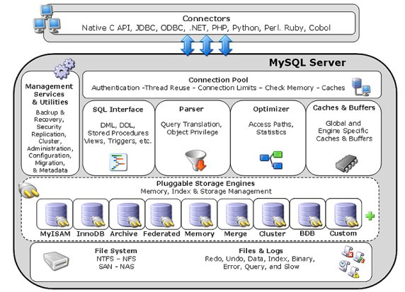

**TEAM STRUCTURE**

We , the two project partners have worked together for the completion of the project “ Hotel management system” . First of all the most important member is our guide “ Mr bryan kerr”. And we have a very good communication with our project guide as well.

**DATAFLOW DIAGRAM (DFD)**

**Process**

**Data Store**

**Source/sink**

**Data flow**

**DFD LEVEL 0**

LOGIN DETAIL

customer

INFORMATION/ROOM

**DFD LEVEL 1**

**Figure: DFD Level 0**

**Customer**

**customer**

updates

reply

**room**

Logout

supply

demand

Booking details

updates

admin

**Room confirm**

**Figure: DFD Level 1**

ENTITY RELATIONSHIP DIAGRAM (ERD)

**Customer**

shares

Asks

worker

Books

paid

has

Update

**messages**

**Hotel**

**manager**

Fixed

has

**Room**

**Figure: E-R DIAGRAM**

**Gnatt chat**

Feasibility study

Coding

Documentation

**DATABASE SCHEMA**

**USERS DATABASE**

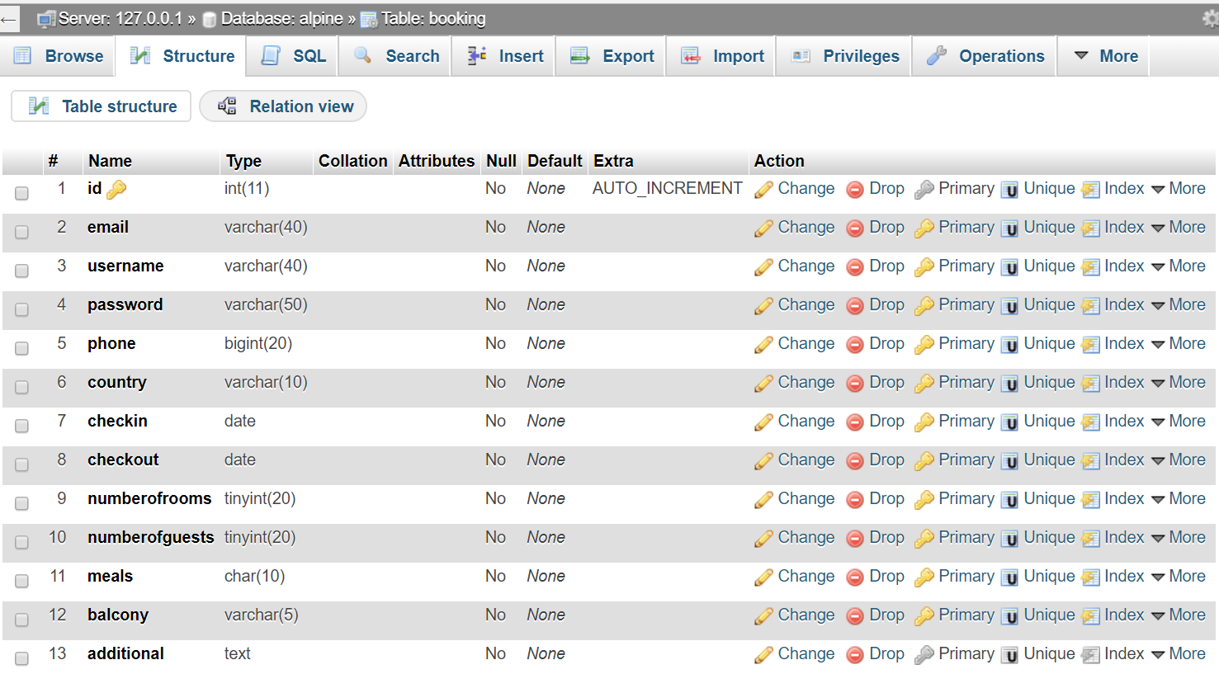

**PROJECT SNAPSHOTS**

**HOME PAGE**

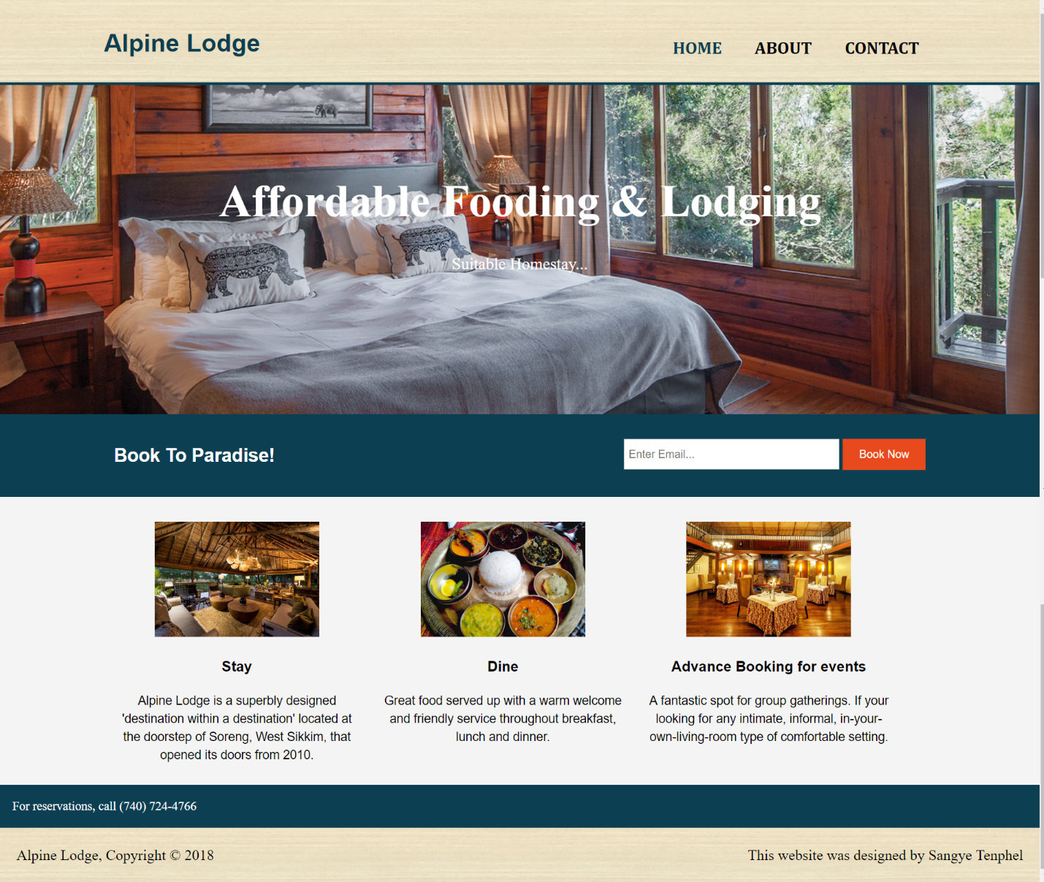

**ABOUT PAGE**

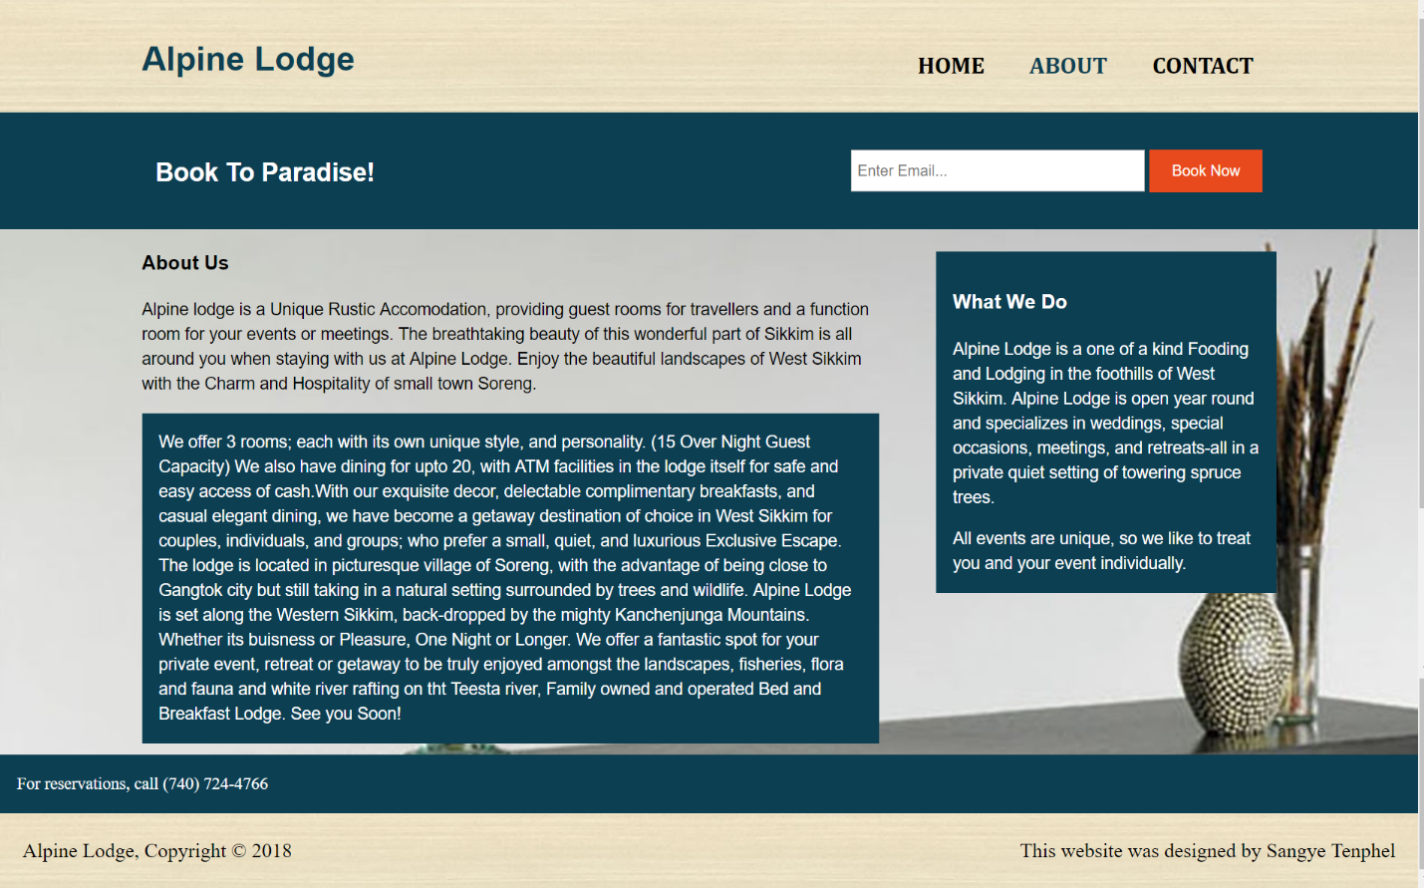

**CONTACT PAGE**

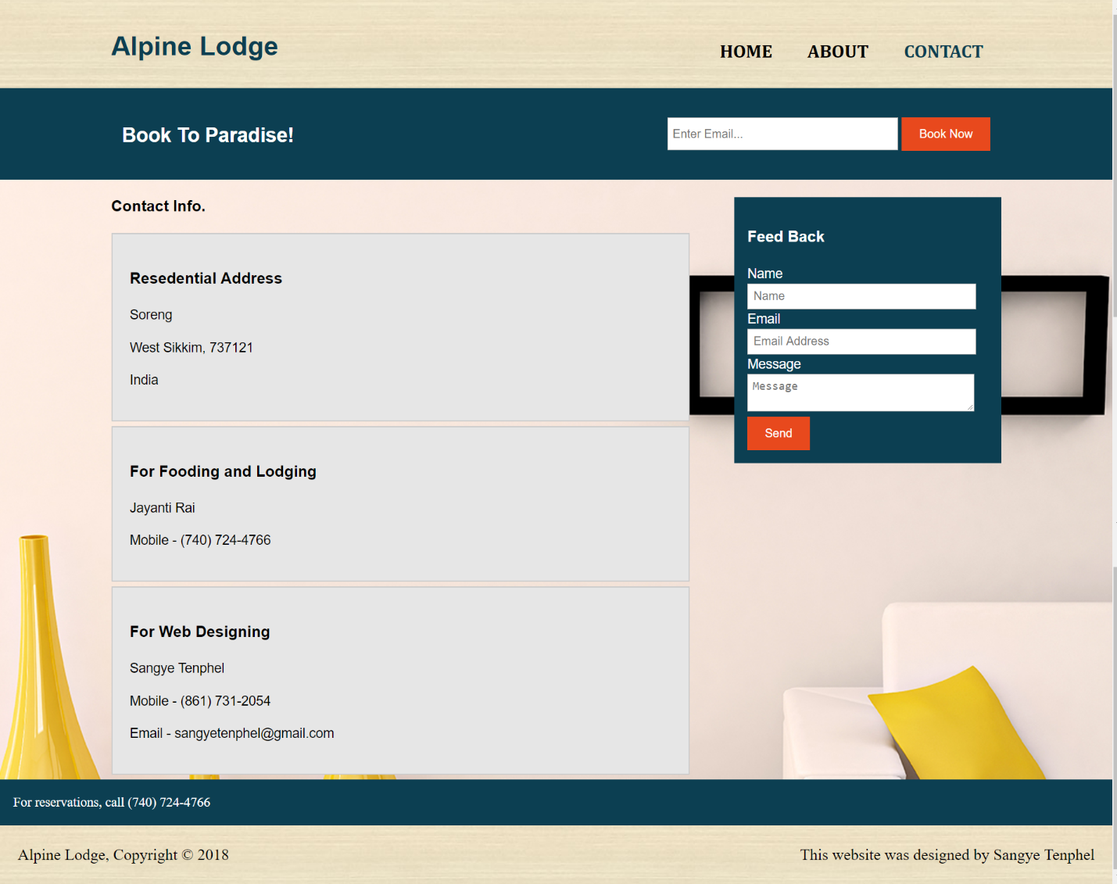

**LOGIN AND REGISRATION PAGE**

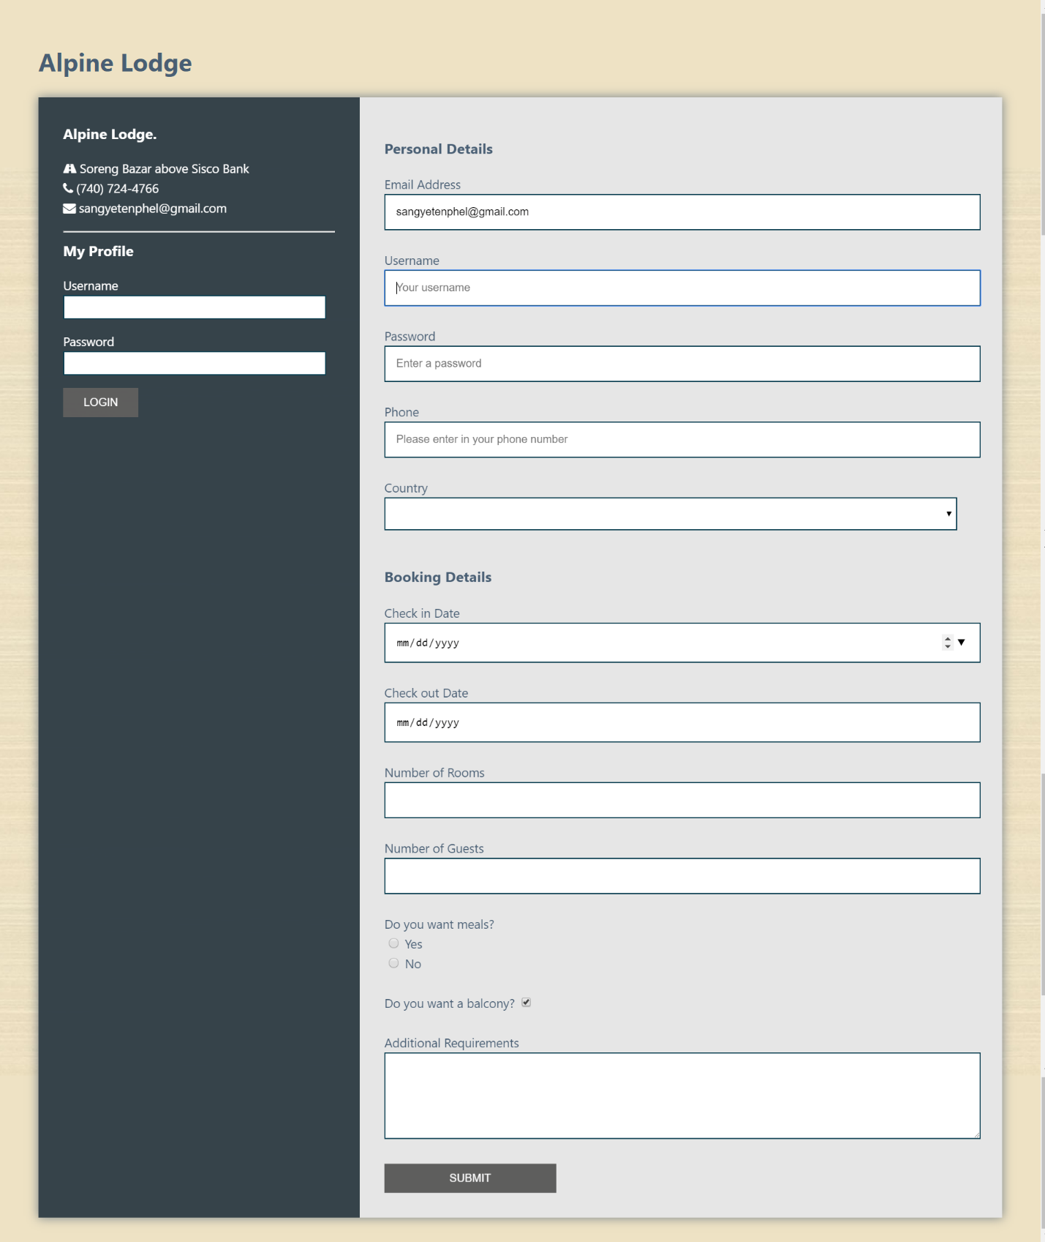

**USER DASHBOARD**

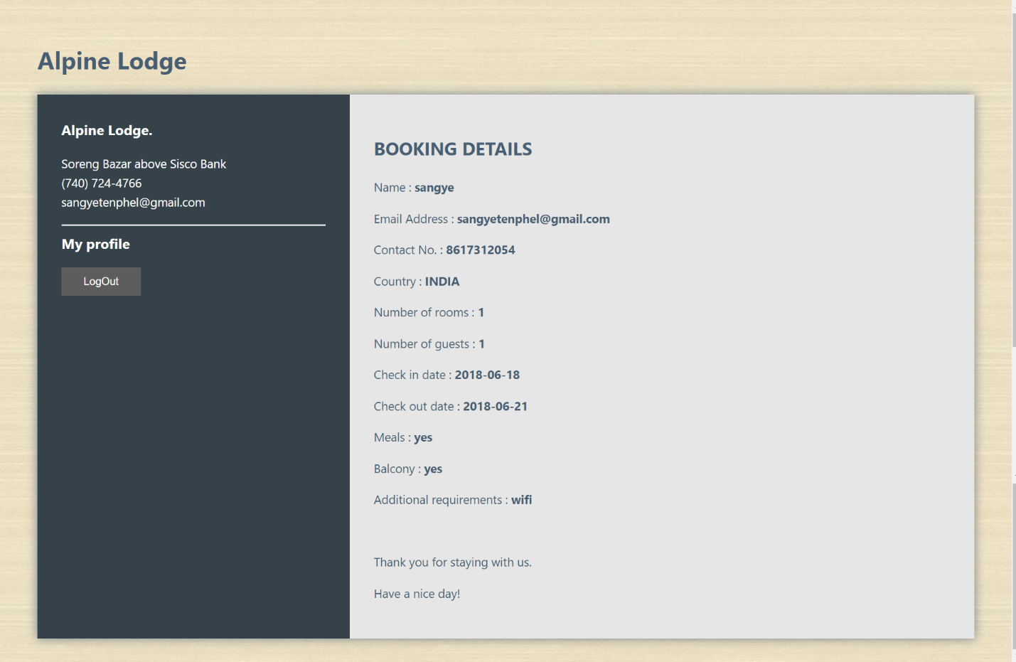

**PROJECT CODING**

**HOME PAGE**

|  |  |
| --- | --- |
| <!DOCTYPE html>  <html>  <head>  <meta charset="utf-8">  <meta name="viewport" content="width=device-width">  <meta name="description" content="Affordable fooding and lodging">  <meta name="keywords" content="lodge, affordable fooding and lodging">  <meta name="author" content="Brad Traversy">  <title>Alpine Lodge | Welcome</title>  <link rel="stylesheet" href="./css/style.css">  </head>  <body>  <header>  <div class="container">  <div id="branding">  <h1><span class="highlight">Alpine</span> Lodge</h1>  </div>  <nav>  <ul>  <li class="current"><a href="index.php">Home</a></li>  <li><a href="about.php">About</a></li>  <li><a href="contact.php">Contact</a></li>  </ul>  </nav>  </div>  </header>  <section id="showcase">  <div class="container">  <h1>Affordable Fooding & Lodging</h1>  <p>Suitable Homestay...</p>  </div>  </section> | <?php  include_once 'newsletter.php';  ?>  <section id="boxes">  <div class="container">  <div class="box">  <img src="./img/stay.jpg">  <h3>Stay</h3>  <p>Alpine Lodge is a superbly designed 'destination within a destination' located at the doorstep of Soreng, West Sikkim, that opened its doors from 2010.</p>  </div>  <div class="box">  <img src="./img/dine.jpg">  <h3>Dine</h3>  <p>Great food served up with a warm welcome and friendly service throughout breakfast, lunch and dinner.</p>  </div>  <div class="box">  <img src="./img/bg.jpg">  <h3>Advance Booking for events</h3>  <p>A fantastic spot for group gatherings. If your looking for any intimate, informal, in-your-own-living-room type of comfortable setting.</p>  </div>  </div>  </section>    <?php  include_once 'footer.php';  ?>  </body>  </html> |

**ABOUT PAGE**

<!DOCTYPE html>

<html>

<head>

<meta charset="utf-8">

<meta name="viewport" content="width=device-width">

<meta name="description" content="Affordable and professional web design">

<meta name="keywords" content="web design, affordable web design, professional web design">

<meta name="author" content="Brad Traversy">

<title>Alpine Lodge | About</title>

<link rel="stylesheet" href="./css/style.css">

</head>

<body>

<header>

<div class="container">

<div id="branding">

<h1><span class="highlight">Alpine</span> Lodge</h1>

</div>

<nav>

<ul>

<li><a href="index.php">Home</a></li>

<li class="current"><a href="about.php">About</a></li>

<li><a href="contact.php">Contact</a></li>

</ul>

</nav>

</div>

</header>

<?php

include_once 'newsletter.php';

?>

<section id="about">

<div class="container">

<article id="main-col">

<h1 class="page-title">About Us</h1>

<p>

Alpine lodge is a Unique Rustic Accomodation, providing guest rooms for travellers and a function room for your events or meetings. The breathtaking beauty of this wonderful part of Sikkim is all around you when staying with us at Alpine Lodge. Enjoy the beautiful landscapes of West Sikkim with the Charm and Hospitality of small town Soreng.

</p>

<p class="dark">

We offer 3 rooms; each with its own unique style, and personality. (15 Over Night Guest Capacity) We also have dining for upto 20, with ATM facilities in the lodge itself for safe and easy access of cash.With our exquisite decor, delectable complimentary breakfasts, and casual elegant dining, we have become a getaway destination of choice in West Sikkim for couples, individuals, and groups; who prefer a small, quiet, and luxurious Exclusive Escape.

<br/>The lodge is located in picturesque village of Soreng, with the advantage of being close to Gangtok city but still taking in a natural setting surrounded by trees and wildlife. Alpine Lodge is set along the Western Sikkim, back-dropped by the mighty Kanchenjunga Mountains. Whether its buisness or Pleasure, One Night or Longer. We offer a fantastic spot for your private event, retreat or getaway to be truly enjoyed amongst the landscapes, fisheries, flora and fauna and white river rafting on tht Teesta river, Family owned and operated Bed and Breakfast Lodge. See you Soon!

</p>

</article>

<aside id="sidebar">

<div class="dark">

<h3>What We Do</h3>

**CONTACT PAGE**

<?php

//define variables and set to empty values

$success="";

if (isset($_POST['name']) && isset($_POST['email']) && isset($_POST['message'])){

$name = $_POST['name'];

$email = $_POST['email'];

$message = $_POST['message'];

$to = 'sangyetenphel@gmail.com';

$subject = "Feedback";

$body = '

<h2>Feedback </h2>

<hr>

<p>Name:<br>'.$name.'</p>

<p>Email:<br>'.$email.'</p>

<p>Feedback:<br>'.$message.'</p>

';

//headers

$headers = "MIME-Version: 1.0" ."\r\n";

$headers .= "Content-type: text/html; charset=iso-8859-1"."\r\n";

$headers .= "From: ".$name."<".$email.">"."\r\n";

$headers .= "Reply-To:" .$email. "\r\n";

$headers .= "X-Mailer:PHP/" . phpversion();

$headers .= "X-Priority: 1"."\r\n";

//send

$send = mail($to, $subject, $body, $headers);

if($send){

$success = "Feedback sent, thank you for helping us!";

}

}

?>

<!DOCTYPE html>

<html>

<head>

<meta charset="utf-8">

<meta name="viewport" content="width=device-width">

<meta name="description" content="Affordable and professional web design">

<meta name="keywords" content="web design, affordable web design, professional web design">

<meta name="author" content="Brad Traversy">

<title>Alpine Lodge | Contact</title>

<link rel="stylesheet" href="./css/style.css">

</head>

<body>

<header>

<div class="container">

<div id="branding">

<h1><span class="highlight">Alpine</span> Lodge</h1>

</div>

<nav>

<ul>

<li><a href="index.php">Home</a></li>

<li><a href="about.php">About</a></li>

<li class="current"><a href="contact.php">Contact</a></li>

</ul>

</nav>

</div>

</header>

<?php

include_once 'newsletter.php';

?>

<section id="main">

<div class="container">

<article id="main-col">

<h1 class="page-title">Contact Info.</h1>

<ul id="services">

<li>

<h3>Resedential Address</h3>

<p>Soreng</p>

<p>West Sikkim, 737121</p>

<p>India</p>

</li>

<li>

<h3>For Fooding and Lodging</h3>

<p>Jayanti Rai</p>

<p>Mobile - (740) 724-4766</p>

</li>

<li>

<h3>For Web Designing</h3>

<p>Sangye Tenphel</p>

<p>Mobile - (861) 731-2054</p>

<p>Email - sangyetenphel@gmail.com</p>

</li>

</ul>

</article>

<aside id="sidebar">

<div class="dark">

<h3>Feed Back</h3>

<form class="quote" action="<?php echo $_SERVER['PHP_SELF']; ?>" method="post">

<div>

<label>Name</label><br>

<input type="text" name="name" placeholder="Name" required>

</div>

<div>

<label>Email</label><br>

<input type="email" name="email" placeholder="Email Address" required>

</div>

<div>

<label>Message</label><br>

<textarea name="message" placeholder="Message" required></textarea>

</div>

<button class="button_1" type="submit">Send</button>

<div class="success"><?= $success; ?></div>

</form>

</div>

</aside>

</div>

</section>

<?php

include_once 'footer.php';

?>

</body>

</html>

h3>

<p>Alpine Lodge is a one of a kind Fooding and Lodging in the foothills of West Sikkim. Alpine Lodge is open year round and specializes in weddings, special occasions, meetings, and retreats-all in a private quiet setting of towering spruce trees.</p>All events are unique, so we like to treat you and your event individually.

</div>

</aside>

</div>

</section>

<?php

include_once 'footer.php';

?>

</body>

</html>

**BOOKING PAGE**

<?php

if (isset($_GET['email'])){

$email = $_GET['email'];

}

?>

<!DOCTYPE html>

<html>

<head>

<meta charset="utf-8">

<meta name="viewport" content="width=device-width">

<meta name="description" content="Affordable fooding and lodging">

<meta name="keywords" content="lodge, affordable fooding and lodging">

<meta name="author" content="Brad Traversy">

<title>Alpine Lodge | Booking</title>

<link href="https://stackpath.bootstrapcdn.com/font-awesome/4.7.0/css/font-awesome.min.css" rel="stylesheet" integrity="sha384-wvfXpqpZZVQGK6TAh5PVlGOfQNHSoD2xbE+QkPxCAFlNEevoEH3Sl0sibVcOQVnN" crossorigin="anonymous">

<link rel="stylesheet" href="https://cdnjs.cloudflare.com/ajax/libs/animate.css/3.5.2/animate.css" />

<link rel="stylesheet" href="./css/style.css">

</head>

<body class="booking">

<div class="container-booking">

<h1><span class="highlight">Alpine</span> Lodge</h1>

<div class="wrapper animated bounceInLeft">

<div class="company-info">

<h3>Alpine Lodge.</h3>

<ul>

<li><i class="fa fa-road"></i> Soreng Bazar above Sisco Bank</li>

<li><i class="fa fa-phone"></i> (740) 724-4766</li>

<li><i class="fa fa-envelope"></i> sangyetenphel@gmail.com</li>

</ul>

<hr/>

<h3>My Profile</h3>

<form action="act-login.php" method="POST">

<p>Username <input type="text" name="username" required /></p>

<p>Password <input type="password" name="password" required /></p>

<button name="submit">Login</button>

</form>

</div>

<div class="contact">

<h3>Personal Details</h3>

<form action="act-register.php" method="POST">

<p>

<label for="email">Email Address</label>

<input type="text" name="email" id="email" value="<?php echo $email?>"required placeholder="Your Email" pattern="[a-zA-Z]{3,}@[a-zA=Z]{3,}[.]{1}[a-zA-Z]{2,}" title="Please enter in a valid email address"><br>

</p>

<br>

<p>

<label for="name">Username</label>

<input type="text" name="username" id="name" required autofocus placeholder="Your username" pattern="[a-zA-Z]{3,}" title="Please enter in more than three letters and no spaces"> <br>

</p>

<br>

<p>

<label for="name">Password</label>

<input type="password" name="password" id="password" required autofocus placeholder="Enter a password"> <br>

</p>

<br>

<p>

<label for="phone">Phone</label>

<input type="tel" name="phone" id="phone" required placeholder="Please enter in your phone number" pattern="[0-9]{10}" title="Please enter in a valid phone number">

</p>

<br>

<p>

<label>Country</label>

<select name="country" required>

<option value=""> </option>

<option value="INDIA">INDIA</option>

<option value="NEPAL">NEPAL</option>

<option value="BHUTAN">BHUTAN</option>

<option value="CHINA">CHINA</option>

</select>

</p>

<br>

<h3>Booking Details</h3>

<p>

<label for="checkin">Check in Date</label>

<input id="checkin" type="date" name="checkin" min="2018-05-27" required>

</p>

<br>

<p>

<label for="checkout">Check out Date</label>

<input id="checkout" type="date" name="checkout" min="2018-05-27" required>

</p>

<br>

<p>

<label for="numberofrooms">Number of Rooms</label>

<input id="numberofrooms" type="number" name="numberofrooms" min="1" max="6" required title="Maximum of 6 rooms">

</p>

<br>

<p>

<label for="numberofguests">Number of Guests</label>

<input id="numberofguests" type="number" name="numberofguests" min="1" max="6" required title="Maximum of 6 people">

</p>

<br>

<p>Do you want meals?</p>

<label for="yesMeals"><input id="yesMeals" type="radio" name="meals" value="yes" required> Yes</label>

<label for="noMeals"><input id="noMeals" type="radio" name="meals" value="no" required> No</label>

<p>

<br>

<label for="balcony"></label>Do you want a balcony?</label>

<input type="hidden" name="balcony" value="no">

<input id="balcony" type="checkbox" name="balcony" value="yes" checked>

</p>

<br>

<p class="full">

<label>Additional Requirements</label>

<textarea name="additional" rows="5"></textarea>

</p>

<br>

<p class="full">

<button>Submit</button>

</p>

</form>

</div>

</div>

</div>

</body>

</html>

**LOGIN PAGE**

<?php

session_start();

$mysqli = NEW MySQLi('localhost','root','','alpine');

$error= ""; //variable to store Error message

$username=$_POST['username'];

$password=md5($_POST['password']);

$resultSet = $mysqli->query("SELECT * FROM booking WHERE username='$username' AND password='$password'") or die("Failed to query datatbase".mysqll_error());

if($resultSet->num_rows !=0){

while($rows = $resultSet->fetch_assoc()){

$username = $rows['username'];

$email = $rows['email'];

$phone = $rows['phone'];

$country = $rows['country'];

$numberofrooms = $rows['numberofrooms'];

$numberofguests = $rows['numberofguests'];

$checkin = $rows['checkin'];

$checkout = $rows['checkout'];

$meals = $rows['meals'];

$balcony = $rows['balcony'];

$additional = $rows['additional'];

}

}else{

$_SESSION['message'] = "Username or Password is invalid";

header("location:booking1.php");

}

?>

<html>

<head>

<link rel="stylesheet" href="./css/style.css">

</head>

<body class="booking">

<div class="container-booking">

<h1><span class="highlight">Alpine</span> Lodge</h1>

<div class="wrapper animated bounceInLeft">

<div class="company-info">

<h3>Alpine Lodge.</h3>

<ul>

<li><i class="fa fa-road"></i> Soreng Bazar above Sisco Bank</li>

<li><i class="fa fa-phone"></i> (740) 724-4766</li>

<li><i class="fa fa-envelope"></i> sangyetenphel@gmail.com</li>

</ul>

<hr/>

<h3>My profile</h3>

<a href="booking1.php"><button>LogOut</button></a>

<?php

$_SESSION['message'] = "Enter Username and Password to login";

?>

</div>

<div class="contact">

<div class="act-register">

<h2>BOOKING DETAILS</h2>

<p>Name : <?php echo '<strong>' .$username. '</strong>'?></p>

<p>Email Address : <?php echo '<strong>' .$email. '</strong>'?></p>

<p>Contact No. : <?php echo '<strong>' .$phone. '</strong>'?></p>

<p>Country : <?php echo '<strong>' .$country. '</strong>'?></p>

<p>Number of rooms : <?php echo '<strong>' .$numberofrooms. '</strong>'?></p>

<p>Number of guests : <?php echo '<strong>'.$numberofguests. '</strong>'?></p>

<p>Check in date : <?php echo '<strong>'.$checkin. '</strong>'?></p>

<p>Check out date : <?php echo '<strong>' .$checkout. '</strong>'?></p>

<p>Meals : <?php echo '<strong>' .$meals. '</strong>'?></p>

<p>Balcony : <?php echo '<strong>' .$balcony. '</strong>'?></p>

<p>Additional requirements : <?php echo '<strong>' .$additional. '</strong>'?></p>

<br>

<p>Thank you for staying with us.</p>

<p>Have a nice day!</p>

</div>

</div>

</div>

</div>

</body>

</html>

</html>

**REGISTRATION PAGE**

<?php

session_start();

$con = mysqli_connect("localhost","root","","alpine")

or die("Failed to connect mysql server ".mysqli_connect_error());

$email = $_POST['email'];

$username = mysqli_real_escape_string($con, $_POST['username']);

$password =md5($_POST['password']);

$phone = mysqli_real_escape_string($con, $_POST['phone']);

$country = mysqli_real_escape_string($con, $_POST['country']);

$checkin = mysqli_real_escape_string($con, $_POST['checkin']);

$checkout = mysqli_real_escape_string($con, $_POST['checkout']);

$numberofrooms =$_POST['numberofrooms'];

$numberofguests =$_POST['numberofguests'];

$meals = mysqli_real_escape_string($con, $_POST['meals']);

$balcony =

mysqli_real_escape_string($con, $_POST['balcony']);

$additional = mysqli_real_escape_string($con, $_POST['additional']);

$query = "INSERT INTO booking(email, username, password, phone, country, checkin, checkout, numberofrooms, numberofguests, meals, balcony, additional)

VALUES('$email', '$username', '$password', '$phone', '$country', '$checkin', '$checkout', '$numberofrooms', '$numberofguests', '$meals', '$balcony', '$additional')";

if(!mysqli_query($con, $query)) {

echo "Error" .mysqli_error($con);

}else{

echo "";

}

?>

<html>

<head>

<link rel="stylesheet" href="./css/style.css">

</head>

<body class="booking">

<div class="container-booking">

<h1><span class="highlight">Alpine</span> Lodge</h1>

<div class="wrapper animated bounceInLeft">

<div class="company-info">

<h3>Alpine Lodge.</h3>

<ul>

<li><i class="fa fa-road"></i> Soreng Bazar above Sisco Bank</li>

<li><i class="fa fa-phone"></i> (740) 724-4766</li>

<li><i class="fa fa-envelope"></i> sangyetenphel@gmail.com</li>

</ul>

<hr/>

<h3>My profile</h3>

<a href="booking1.php"><button>LogOut</button></a>

<?php

$_SESSION['message'] = "Enter Username and Password to login";

?>

</div>

<div class="contact">

<div class="act-register">

<h2>BOOKING DETAILS</h2>

<p>Name : <?php echo '<strong>' .$username. '</strong>'?></p>

<p>Email Address : <?php echo '<strong>' .$email. '</strong>'?></p>

<p>Contact No. : <?php echo '<strong>' .$phone. '</strong>'?></p>

<p>Country : <?php echo '<strong>' .$country. '</strong>'?></p>

<p>Number of rooms : <?php echo '<strong>' .$numberofrooms. '</strong>'?></p>

<p>Number of guests : <?php echo '<strong>'.$numberofguests. '</strong>'?></p>

<p>Check in date : <?php echo '<strong>'.$checkin. '</strong>'?></p>

<p>Check out date : <?php echo '<strong>' .$checkout. '</strong>'?></p>

<p>Meals : <?php echo '<strong>' .$meals. '</strong>'?></p>

<p>Balcony : <?php echo '<strong>' .$balcony. '</strong>'?></p>

<p>Additional requirements : <?php echo '<strong>' .$additional. '</strong>'?></p>

<br>

<p>Thank you for staying with us.</p>

<p>Have a nice day!</p>

</div>

</div>

</div>

</div>

</body>

</html>

**TESTING**

In the testing phase we provided wrong information to website to check if validation work or not.

|  |  |  |  |
| --- | --- | --- | --- |
| Page | Value Given | Actual Value | Result |
| User Login | Username: Sangye  Password: 1111 | Username: Sangye  Password: 123 | Username or Password is invalid |
| User Login | Username:  Password: | Username: Sangye  Password: 123 | Enter Username and password to login |

FURTURE SCOPE

This project will have a very bright future in if the following incorporated

* Adding a live weather widget showing the weather of the lodge’s location.
* Aritificial Intelligence, Virtual Reality and Augmented Reality images and videos of rooms, sites etc. for better user experience.

Again we like to bring to notice that right now the project is limited only for BCA Department and we would like to incorporated databases of all other Department too. so that this website is accessible to everyone.

**CONCLUSION**

Alpine Lodge is a website which can be easily accessed by the customer. Anyone can easily book their stay at that place. It is beneficial sites for the people looking for a place to stay at a particular place at a reasonable rate.

On realizing the importance of systematic documentation all processes are implemented systematically using software engineering approach. We have gained lot of practical knowledge from this project which will be beneficial for us in future.

**BIBLIOGRAPHY**

We would like to first of all thank our mentor Mr. Anirban Maitra for his help and support. We took references from the following sources:

* [www.google.co.in](http://www.google.co.in)
* [www.w3schools.com](http://www.w3schools.com)
* [www.stackoverflow.com](http://www.stackoverflow.com)

We would also like to thank our special mentor Mr. Bryan Kerr for his help and support.